CONTENTS

1.0 Introduction 2

1.1 Purpose 2

1.2 Scope 2

1.3 Corporate References 2

1.4 Tools and Templates 3

1.5 Records Retention 3

2.0 Definitions 3

3.0 Roles and Responsibilities 5

3.1 Refining Safety and Security Manager 5

3.2 Corporate Refining HES Professional 6

3.3 Cellular Services 6

3.4 Refinery Safety Supervisors 6

4.0 Approval Process 6

4.1 Electronic Device Approval Process 6

4.2 Contractor Device Approval Process 7

5.0 Safety Considerations 8

5.1 Electronic Device Use in Restricted Areas 8

5.2 Electronic Device Use in Vehicles within the Refinery 8

5.3 Personal Electronic Device Use in Central Control Rooms and Operator Boards / Consoles 9

5.4 Personal Electronic Devices Use in Maintenance Shops 9

6.0 Security 9

6.1 Recording Proprietary Information with Electronic Devices 9

7.0 Program Review 10

7.1 Procedure Review 10

8.0 Review and Revision History 10

8.1 History of Revisions 10

Appendix A Criteria for Electronic Device Approval 11

A.1 Minimum Requirements 11

A.2 Portable Electronic Product (PEP) Requirements 11

A.3 PEP1 Requirements 11

A.4 PEP2 Requirements 11

A.5 Radio Frequency 12

A.6 Drop Test 12

A.7 Power On- Off Switches 12

A.8 Contractor Electronic Device Form 13

A.9 Contractor Approved-for-Use Decal 15

A.10 Process to Obtain MPC Approved Cases per Device 16

LIST OF TABLES

Table 1 Terms and Definitions 3

Table 2 Revision History 10

Table 3 Approved Electronic Cases per Device 16

Introduction
Purpose | This policy provides guidance on the use, control, and approval process for Electronic Devices inside and within the Restricted Areas of the Martinez (MTZ) Renewable Fuels - Marathon Petroleum Company LP (MPC).
Scope | This Rule and Standard Instruction (RSI) outlines the acceptable use of Company owned, issued, and approved Electronic Devices and Personal Electronic Devices at MTZ Renewable Fuels, including but not limited to all process areas electrically classified as Class I, Division 1 or 2 in accordance with ISA 12.12.03. All personnel, including MPC employees, contract workers, and visitors are subject to this RSI.  Use of an Intrinsically Safe Electronic Device, including any Portable Electronic Product (PEP), which complies with ISA 12.12.03, is permissible when consistent with this policy.  Use of Personal Electronic Devices, either intrinsically safe or non-intrinsically safe, is limited to prevent safety hazards in areas that are restricted, have hazardous classifications or are at high risk for ignition.  Any Electronic Device, whether intrinsically safe, Company Approved Electronic Device or non-intrinsically safe, with video, recording, or photo capabilities presents a security risk to MPC. Mitigation of such risk supports the restrictions outlined herein.
References | The following sections describe references used to generate this document.  Martinez Renewable Fuels RSI  - RSI – 08-01 Safe Work Permit  - RSI – 08-04 Hot Work  - RSI - 08-36 Vehicle Safety  Marathon Standards, Policies & Procedures  - REF-1056 – Safe Use of Electronic Devices  - Policy 10006 Recording  Industry Standards  - ISA 12.12.03 Standard for Portable Electronic Products Suitable for Use in Class I and II, Division 2, Class I Zone 2 and Class III, Division 1 and 2 Hazardous (Classified) Locations
Tools and Templates | The following forms are available for use with this policy:  - RSI-08-22-F01 Contractor Electronic Device Form.
Records Retention | Printed copies of this document should not be retained more than 12 months. Any revision to this document will be retained indefinitely.

Definitions
The following terms and definitions are used in this document.

Table 1 Terms and Definitions
Term | Definition
Company Approved Electronic Device | Company Approved Electronic Devices are Electronic Devices (other than Contractor Issued Electronic Devices) that are not owned or issued by MPC (i.e., approved personal devices).  Use of such devices must be vetted and approved by local management.  Personal Devices enrolled in the Bring Your Own Device (BYOD) program are considered Company Approved Electronic Devices and will require a Hot Work Permit if used in a restricted area.
Company Issued Electronic Device | Company Issued Electronic Devices are MPC owned/issued Electronic Devices or Electronic Devices reimbursed by MPC for individuals’ business use in the course and scope of providing services to MPC.  Company Issued Electronic Devices with an MPC Rugged Case satisfy the criteria in ISA 12.12.03 and are approved for use in certain hazardous (classified) locations (i.e., Class I, Division II).
Contractor Issued Electronic Device | Contractor Issued Electronic Device is any intrinsically safe or non-intrinsically safe device, including but are not limited to a:  cellular phone,  two-way phone/radio,  personal data or digital assistant (PDA),  iPad,  tablet, and  similar devices.  These Electronic Devices are Issued by their employer and must satisfy the criteria in Section 4.2 before they can be brought into or used in a Restricted Area.
Electronic Device | Electronic Device is any intrinsically safe or non-intrinsically safe device, including but are not limited to a:  cellular phone,  two-way phone/radio,  personal data or digital assistant (PDA),  iPad,  iPod,  tablet,  Kindle,  smart watch (e.g., Apple Watch),  wearable technology (e.g., Google Glass),  media steaming devices (e.g., Amazon TV), and  similar devices.
Inside or Within the Renewable Fuels Site | Inside or Within MTZ Site, is any area within the perimeter of Company owned, leased, or managed property, up to but not limited to:  inside and outside battery limits,  process units,  operations shelters,  tank dikes,  docks,  satellite buildings,  control rooms,  control board areas,  shops,  office buildings,  maintenance buildings,  turnaround buildings,  contractor buildings,  warehouses,  blast resistant modules,  permanent/temporary buildings or structures, whether or not occupied,  laydown yards,  parking areas, and  any area in which the minimum requirements for standard PPE apply.
Intrinsically Safe Device | Intrinsically Safe Device is an Electronic Device clearly identified by or with factory- labeling as “Intrinsically Safe,” “Explosion Proof” or labeled as approved for use in hazardous locations rated as Class I, Div. 1 or 2.
MPC Rugged Case | MPC Rugged Case is a case reviewed and pre-approved by the Refining Safety and Security Manager using process outlined in Appendix A that has been proven to pass a drop test. The device with its protective case will be deemed acceptable in lieu of performing a drop test on Company Electronic Devices.
Outside the Site | Outside the MTZ Renewable Fuels Site is any area not considered inside or within the site.
Personal Electronic Device | Personal Electronic Device is a non-Company owned, issued, or approved Electronic Device. Use of such devices must be vetted and approved by local management.
Portable Electronic Product (PEP) | Portable Electronic Product is a battery-powered or photovoltaic cell-powered apparatus that can be hand-held or that is intended for use while worn on a person’s body.
PEP1 | PEP1 is a body-worn electronic product, in direct contact with the skin that is deemed incapable of causing an ignition under normal conditions such as a wrist watch, smart watch, hearing aid, or wrist-worn personal fitness tracker.
PEP2 | PEP2 is a portable electronic product that is deemed incapable of causing an ignition under normal conditions, such as approved cellular phones or tablets.
Proprietary Information | Proprietary Information is:  - attorney-client privileged information,  - non-public financial and operating results,  - trade secrets,  - patents,  - intellectual property,  - licensing agreement or copyrighted material, or  - information that provides competitive insights to development of systems, processes, products, know-how, and technology.
Restricted Area | Restricted Areas include areas within the process units (both inside and outside battery limits), tank dikes, docks, satellite buildings, and any area in which the minimum requirements for standard PPE apply.
HES | Health, Environment, and Safety

Roles and Responsibilities
Refining Safety and Security Manager | The Refining Safety and Security Manager is responsible for:  - Establishing a process to ensure approved case/device are available for personnel through Cellular Services and/or 3rd Party.  - Reviewing and approving Portable Electronic Products (PEP) for use within hazardous environments as “PEP2” devices.  - Maintaining an approved device/case list and updating as new devices/cases are approved.
Cellular Services | Cellular Services is responsible for:  - Receiving approved devices from the Refineries and ensuring they are approved per the file of approved devices/cases kept by Corporate Refining HES Professional.  - Ensuring approved cases are etched with MPC Logo.  - Distributing approved cases to the Refinery personnel who are authorized by their supervisor to have an “MPC Rugged Case” approved for use in hazardous locations.
Martinez Safety Supervisor | Safety Supervisors is responsible for:  - Incorporating this policy into any existing site policy on mobile devices. Implementation of this policy must be in compliance with existing collective bargaining agreements.  - Establishing a process to document personnel who have a business need for an approved case/device and the process for ordering approved devices/cases through a 3rd party and sending to Cellular Services for MPC Logo.  - Reviewing and approving Contractor Portable Electronic Products (PEP) for use within hazardous environments as “PEP2” devices.

Approval Process
Electronic Device Approval Process | - Any new types of non-intrinsically safe Company Electronic Devices to be used at MTZ, outlined in Section 5.0 of this policy, must be approved by the Safety Supervisor if the device is to be used without a hot work permit in order to determine an appropriate case for the hazard location.  Note: The Safety Supervisor will utilize the approval process outlined in Appendix A of this policy.  - Any device that no longer meets the requirements of Appendix A (e.g., cracked screen, broken case or port covers, etc.) no longer met the requirements of ISA 12.12.03 and shall be removed from service.
Contractor Device Approval Process | - Contract Companies with a legitimate business purpose may use Contractor - Issued Electronic Devices within MTZ locations outlined in Section 5.0 of this policy. Contractor Issued Electronic Devices shall meet one of the following criteria:  - Electronic Device clearly identified by or with factory-labeling as “Intrinsically Safe”, “Explosion Proof” or labeled as approved for use in hazardous locations rated as Class I, Div. 1 or 2,  - Establish an approval process consistent Appendix A of this document, or  - Obtain a Hot Work permit.  - Utilize Appendix A of this procedure to approve Contractor Issued Electronic Devices shall ensure:  - The form is completed by the requesting contract company and supporting documentation is provided to MPC Safety Supervisor for retention, and  - Once approved by MPC Safety Supervisor for use within Restricted Areas, the MPC Safety Supervisor shall apply the “Contractor Approved for Use” decal (see Figure 1 on page 14 of this document).  - If the Electronic Device or case becomes damaged the Electronic Device is no longer approved for use.

Safety
Electronic Device Use in Restricted Areas | - Only an Intrinsically Safe or Company Approved Electronic Device as defined herein is permitted within Restricted Areas. Company issued devices specifically intended for use within the Restricted Areas, such as radios, RADAR handhelds, etc., do not require additional approval prior to use.  - Possession of any personal, non-Intrinsically Safe Electronic Device whether powered on or off, is strictly prohibited in Restricted Areas, with the exception of personal medical devices. Non-Intrinsically Safe Electronic Devices should be stored and used only in vehicles, offices, locker rooms, or designated lunch/break areas.  - Non-Intrinsically Safe Personal Medical Devices (e.g., insulin pump) require the user to wear a four-gas meter in lieu of obtaining a Hot Work permit. If the four-gas meter alarms, the person must evacuate immediately to a safe location.  - Use of a non-Intrinsically Safe Company Electronic Device or Company Approved Electronic Device for use in hazardous locations in a Restricted Area shall serve a legitimate business purpose, be approved by MTZ management, and be accompanied by a Hot Work permit.  - Electronic Devices, with the exception of radios, may not be used while moving through the unit (e.g., walking or climbing). No external electrical or wireless connections or accessories, including ear buds, headphones, or Bluetooth technologies, are permitted to be used in any Restricted Area. Phone conversations are prohibited where hearing protection is required.
Electronic Device Use in Vehicles within MTZ Site | - Use of any Electronic Device while driving a vehicle or operating equipment within the site is strictly prohibited, this includes wireless, Bluetooth, or hands-free communication technology, in accordance with RSI 08-36 Vehicle Safety. Prohibited usage includes but is not limited to texting, instant messaging, reading or sending messages or e-mails, receiving or making phone calls, and/or taking pictures, videos, or recordings.  - Electronic Device use within vehicles is permissible when riding as a passenger or the vehicle or equipment is pulled over in a safe location, out of the way of traffic/work, and parked at a complete stop prior to the user engaging in any of the above-listed activities and should serve a legitimate business purpose.  - Equipment subject to this prohibition includes but is not limited to cars, trucks, forklifts, man-lifts, cherry pickers, cranes, golf carts, all terrain buggies, bicycles, or anything similar in nature.
Personal Electronic Device Use in Central Control Rooms and Operator Boards / Consoles | - To ensure security and avoid safety distractions, Personal Electronic Devices can only be used or charged at the consoles/boards at the discretion of the Owning Department Manager. Personal Electronic Devices should be stored in vehicles, offices, locker rooms or designated lunch or break areas.  - Use of Company Electronic Devices or Company Approved Electronic Devices, including Company computer stations in the control rooms, shall be in accordance with RSI-08-22 and REF-1056 Safe Use of Electronic Devices.
Personal Electronic Devices Use in Maintenance Shops | - Possession of Personal Electronic Devices, either intrinsically safe, Company Approved Electronic Device or non-intrinsically safe, whether powered on or off is limited in Maintenance Shops at the discretion of the Owning Department Manager. Use of Personal Electronic Devices should be restricted to non-working time, including break periods, in designated lunch or break areas, locker rooms, offices, external parking areas and during transition to and from the gate, such as before and after shift.

Security
Recording Proprietary Information with Electronic Devices | - The use of Electronic Devices to record and distribute Proprietary Information at MTZ will comply with all company policies, including but not limited to MPC Policy 10006, Policy 12002, and Policy 12003, and be consistent with the site Facility Security Plan (FSP) requirements.  - Recording is permissible if it otherwise complies with this policy and the recording is for a legitimate business purpose, unless such Recording adversely affects or compromises:  - a company trade secret or provides competitive insight to development of systems, processes, products, know-how, and technology,  - legal patents, intellectual property, licensing agreements or copyrighted material,  - attorney-client privileged information, including information related to pending enforcement or litigation,  - business development information subject to a confidentiality agreement, or  - non-public financial or operational information or results subject to Policy 12002.

Program Review
Procedure Review | This document will be reviewed every 3 years.

Review and Revision History
History of Revisions | The Table 2 provides the revision history for this document.

Table 2 Revision History
Revision | Date | Change Author | Reason for Change
0 |  |  | Original Issue

- Criteria for Electronic Device Approval
- Minimum Requirements | In order to use an Electronic Device in a hazardous environment without a Hot Work permit, the device alone and/or device and case must meet the minimum requirements established in ISA 12.12.03.
- Portable Electronic Product (PEP) Requirements | The following requirements in this policy classify a device as a Portable Electronic Product (PEP):  - Radio frequency energy transmission limited in accordance with Section A.5,  - No provisions for forced ventilation (e.g., does not contain a fan),  - No sparks visible during operation,  - No camera flash unless it is mechanically disabled,  - No motors unless it can be demonstrated the motor incorporates non-arcing, and  - No visible damage which compromises the structural integrity of the phone or case.
- PEP1 Requirements | PEP1 devices can be used in a classified area without a Hot Work permit. PEP1 devices must meet the following criteria:  - Powered by a maximum of two button cells,  - Body-worn and in direct contact with the skin, and  - No external electrical connections or accessories are used in the hazardous (classified) location.  Examples: Wrist Watches, Smart Watches, Fitness Trackers, and medical devices (e.g., hearing aids, etc.)
- PEP2 Requirements | In order to determine if a PEP can be used in a classified area without a Hot Work permit, it must be on the list of preapproved devices with/without required protective casing as detailed in Appendix A. The Martinez Safety and Security Manager will use the following criteria in its evaluation:  - Powered by one or more cells, batteries, or photovoltaic cells,  - Cell or battery secured so it will not fall out in the drop test as described Section A.6,  - Body-worn or hand held,  - No external electrical connections or accessories are used in the hazardous (classified) location,  - Exposed terminals (for example battery charging terminals) are either recessed or diode protected to prevent a discharge caused by an accidental shorting of these terminals,  - Power switch in accordance with Section A.7, and  - No damage that exposes the electrical/electronic circuitry as a result of the drop test described in Section A.6.  Note: PEP2 devices may be used in a classified area with a Hot Work permit. For PEP2 Medical Devices (e.g., insulin pump), user will wear a four-gas meter in lieu of obtaining a hot work permit.  If a device or device and case are approved; this device will then be allowed to be used in Class I, Division 2 areas without a Hot Work permit. Only devices that are approved and labeled will be allowed.  MPC’s Approved Case will be a Black/Yellow Lifeproof Case with the Marathon “M” logo on the back available through Cellular Service.  Note: Approved devices will not be allowed in Class 1, Division 1 areas without a Hot Work permit. This includes areas where ignitable concentrations of flammable vapors can exist under normal conditions, possibly due to operational activities, line-breaks, repair, or leakage.
- Radio Frequency | The radiated radio frequency energy from a device, such as a radio or cell phone, is not considered an ignition source if it is below the following limits:  - 2 watt (W) maximum output averaged over 20 microseconds for Groups A and B and Group IIC,  - 3.5 W maximum output averaged over 100 microseconds for Group C and Group IIB, or  - 6 W maximum output averaged over 100 microseconds for Group D and Group IIA  Note: Most cell phones radiate under 2 W so their level of radio frequency radiation is acceptable for PEP2 products.
- Drop Test | For PEP20, the device shall be capable of passing a drop test. The test requires the device (or a sample of the product) in the form in which it is intended to be used to be dropped onto a horizontal concrete surface from a height of 2 meters (6 feet, 6 inches). The test is repeated 6 times with the device being dropped in the 6 orientations that are considered most likely to cause a failure. At the conclusion of the testing, the integrity of the case shall not have been compromised, the battery shall not have fallen out or become disconnected, and the device shall operate as intended.  Note: If the device is in a pre-approved case that has been proven to pass a drop test, the device with its protective case will be deemed acceptable in lieu of performing a drop test on company issued devices.
- Power On- Off Switches | Any device with a power on-off switch with contacts that directly interrupt battery current is not acceptable for PEP2 because the switch may cause an ignition-capable arc.  Note: If the switch operator is not a maintained position device and requires the same action for on and off, then it is likely to be an electronic switch. Generally, electronic products use the electronic circuit type of switch.
- Contractor Electronic Device Form | The following shows the Contractor Electronic Device Form (RSI-08-22-F01).

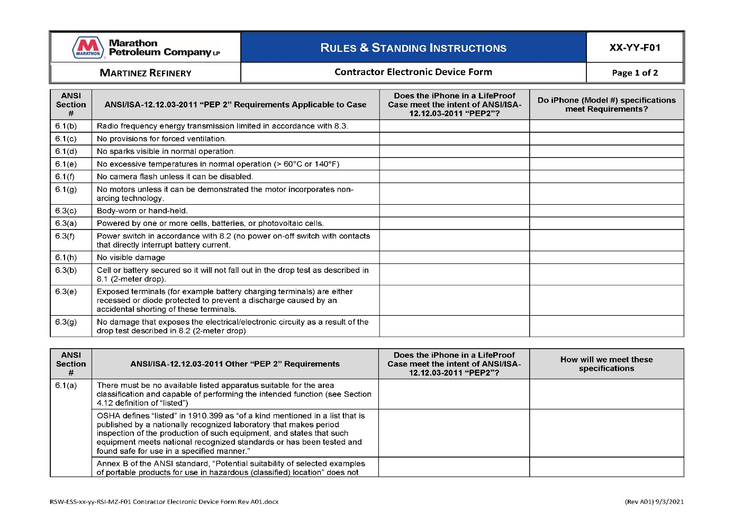

Figure 1 Contractor Electronic Device Form (Page 1 of 2) (RSI-08-22-F01)

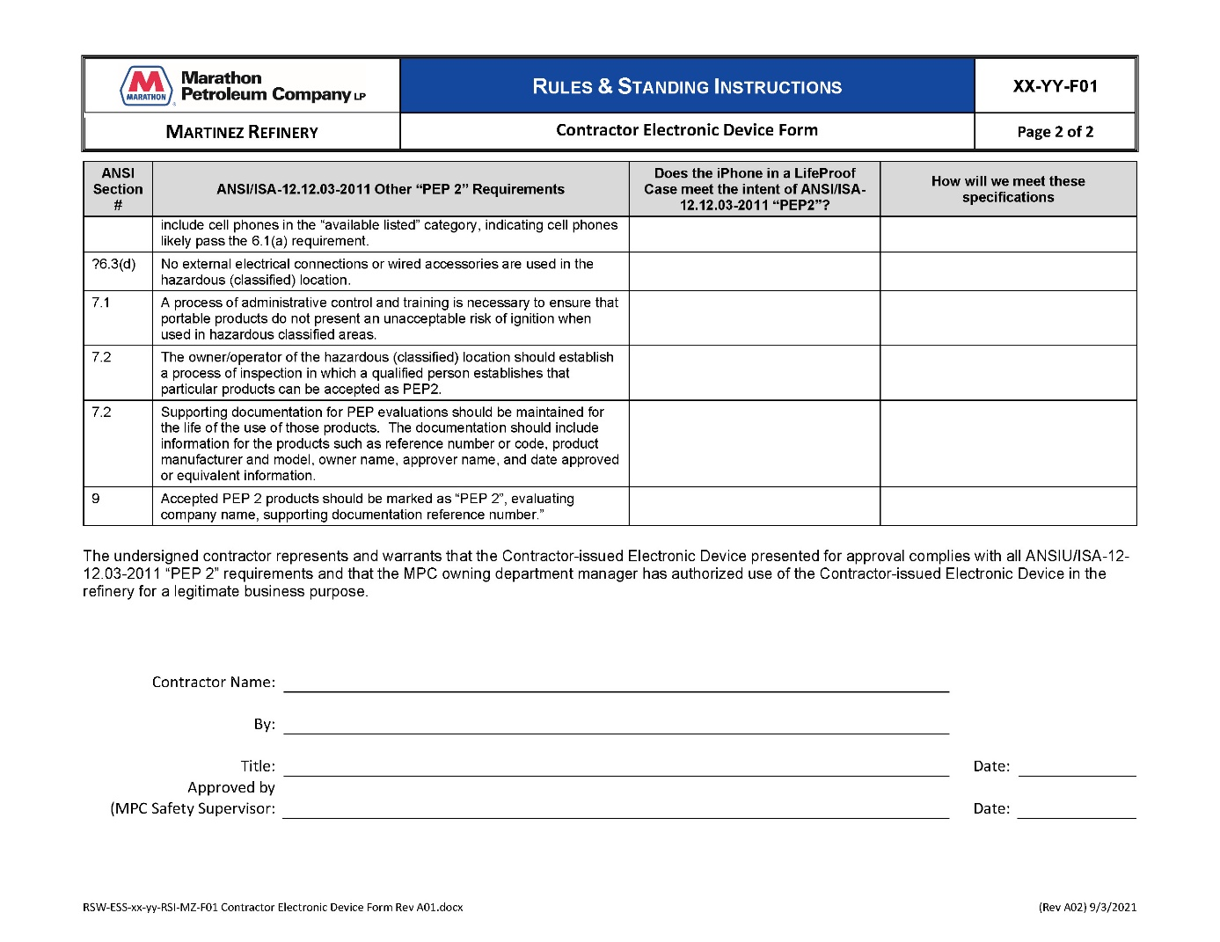

Figure 2 Contractor Electronic Device Form (Page 2 of 2) (RSI-08-22-F01)

- Contractor Approved-for-Use Decal | The picture in Figure 1 depicts the decal that is to be applied to a Contractor Issued Electronic Device that has been approved for use.

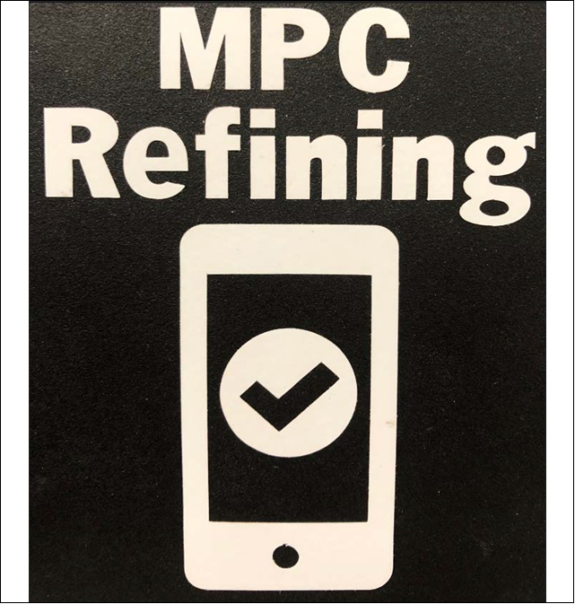

Figure 3 Contractor Approved-for-Use Decal

- Process to Obtain MPC Approved Cases per Device | The following devices and cases have been approved per Appendix A. The table below outlines the link to purchase the approved case. Any deviation from this matrix must be approved by the Corporate Refining Safety and Security Manager.  Each Refinery shall order their approved case through the link in Table 3 and send intercompany mail to Cellular Services with the following information:  - List of Names of individuals  - Cost Center to Bill Logo, and  - Return Shipping Address and Attention To Name.

Table 3 Approved Electronic Cases per Device
Phone | Case | Link to Order | Approved Color
iPhone 6 | LifeProof FRE | Order iPhone 6 Amazon | Black Case with Gray Stripe
iPhone 6s | LifeProof FRE | Order iPhone 6s | Black Case with Gray Stripe
iPhone 6 Plus | LifeProof FRE | Order iPhone 6+ | Black Case with Gray Stripe
iPhone 6s Plus | LifeProof FRE | Order iPhone 6s+ | Black Case with Gray Stripe
iPhone 7 | LifeProof FRE | Order iPhone 7 | Black Case with Lime Green Stripe
iPhone 7 Plus | LifeProof FRE | Order iPhone 7+ | Black Case with Gray Stripe
iPhone 8 | LifeProof FRE | Order iPhone 8 | Black Case with Lime Green Stripe
iPhone 8 Plus | LifeProof FRE | Order iPhone 8+ | Black Case with Lime Green Stripe
iPhone X | LifeProof FRE | Order iPhone X | Black Case with Lime Green Stripe
iPhone XR | LifeProof FRE | Order iPhone XR | Black Case with Gray Stripe
iPhone 11 | LifeProof FRE | Order iPhone 11 | Black Case with Gray Stripe
iPhone SE (2020) | LifeProof FRE | Order iPhone SE 2020 | Black Case with Lime Green Stripe

