Welcome to the Catlettsburg Refinery (CBG)!
The Contractor Safety Council (CSC) has developed this packet to provide information about the site entry requirements, safety policies, life critical safety rules, work instructions and a list of frequently used forms.
To electronically access this information, go to:
https://mpcext.sharepoint.com/sites/MPC-CBG-Safety-docs
(See pages 26-27 for login information)

Also included is the “MPC Contractor Pre-Arrival Checklist”. This valuable tool is designed to help your Company meet Marathon Petroleum’s (MPC) requirements to work onsite.

The CSC consists of nested and long-term Contractor Safety Representatives at CBG. It is designed to provide a voice for Contractors to the CBG Safety Team and the Refinery Leadership Team. The CSC actively works with MPC to enhance the overall safety performance and to build positive relationships with everyone in the facility.

Feel free to contact any member of the CSC if you have any questions or any
additional information.

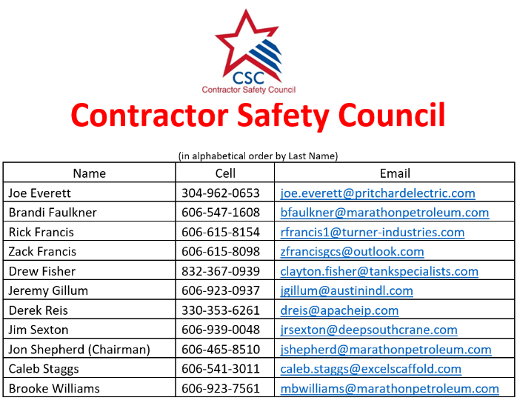

Site Entry Requirements

Drug and Alcohol Program
- Contract Employees must be enrolled in an MPC approved Drug and Alcohol Test program.
- To obtain an account, contact DISA's Sales Department at 281-673-2530 or sales@disa.com.
- Contract Employees status must be tested in an MPC approved program prior to coming onsite. Any Contract Employee not "green-lighted" will not be allowed onsite.
- Nursing Corp: 606-921-3631
    - Location: McComis Dr. Catlettsburg, KY 41129
    - Hours: Monday – Thursday (7:00 a.m.- 5:30 p.m.)
TAR Hours: TBA
TWIC®

Reference website below for TWIC requirements

- https://tsaenrollmentbyidemia.tsa.dhs.gov/

Onsite TWIC Office: 606-921-2979

Hours: Monday- Thursday (6:00a.m.- 4:00p.m)

Background Check
  - Contract Employees must pass a background security check from one of the following background check providers: (These are the
currently approved MPC background check providers)
    - DISA Global Solutions
    - First Advantage
    - Guidepost Solutions LLC
    - S2 Verify

Orientation

Contractor Orientation Requirements
All contract workers must take and successfully complete the following MPC approved site-specific training requirements (in English) through the Health and Safety Council (HASC) prior to obtaining a Contractor Badge:
Catlettsburg Required Health and Safety Training Requirements
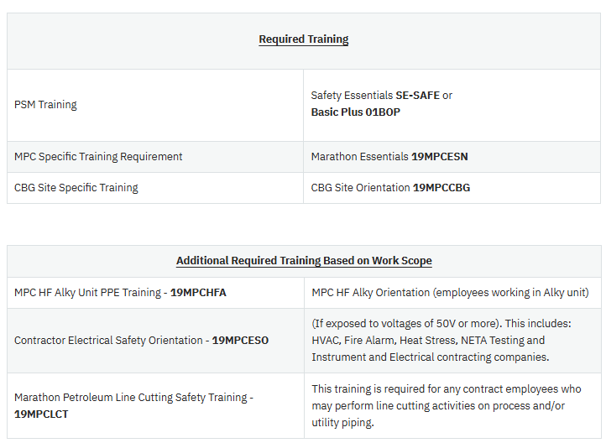

Orientation Cont.

All required training can be completed Remotely Online, In-Person at an approved Safety Council Location, or In-Person at the Regulatory Training Center (RTC) located outside of Catlettsburg Refinery during normal business hours.
1. Remotely Online - https://www.hasc.com/
- Contract companies must create an account with the HASC and then register employees to take the required courses through the LINK account. Quick Start Guide
- Courses are Live Online Proctored
- Courses can be taken Monday - Friday 7am - 7pm EST (Extended hours will be posted on their website HASC Hours
2. HASC Approved Safety Council Locations Approved Locations
3. Regulatory Training Center (RTC) - Phone 606-921-2992
Online Proctoring will require a computer with a webcam and microphone capabilities. Please reach out to HASC with any questions regarding Live Online Proctoring.
Contractors will be allowed to obtain an access badge after they successfully complete the PSM Training, MPC Essentials, CBG Site Specific, and HF Alky(if required). Once these courses have been successfully completed all employees are required to provide proof of enrollment in DISA and pass an MPC approved background security check.

Refinery Access/ID Card (Lenel ID Badge)
  - Complete CBG badge request form before sending new hire or rehire to facility.
  - Contract employees will obtain their Refinery Access ID Card at the Refinery Security & Badging office at the following address:
England Hill Training Center 7716 McComis Drive
Catlettsburg, KY 41129

Hours: Monday - Thursday (6:00 a.m.-4:00 p.m.)
All other inquires go to Central Gate
Phone: 606-921-2982
  - The following is required and will be verified by Refinery Security prior to issuing the Refinery Access ID Card:
    - Drug and Alcohol testing compliance
    - Background Check/TWIC
    - Successful completion of orientation and site-specific training
NOTE: Individuals must present a valid picture ID to receive their Refinery Access ID Card.
  - Contractor Employees must always keep the Refinery Access ID Card in their possession while on refinery property.
    - When completing CBG badge request form, for your personal will be operating contract company vehicles they will need to request a “Blue Pass” ensure you request this upon entry. All company vehicles must display signage.
Employee Parking
  - Merit Companies – parking lot is located on U.S. 23 West of the Central Gate.
  - Non-Merit Companies – parking lot access road is located at the first right on Marathon Way off U.S. 23.
  - Parking Pass – Security will issue a hanging tag that must always be displayed on the rearview mirror. The tag will include your Lenel badge number.

Evacuations
All Contractors must understand the Catlettsburg Refining emergency response procedures as outlined below.

COMPLEX EVACUATION
- In case of fire/explosion and/or toxic material release (i.e., hydrofluoric acid, hydrogen sulfide, etc.), the refinery emergency alarm (Whelan System) will sound.
- Upon hearing the alarm, Contract Employees must shut down all powered equipment and leave the job site immediately, proceeding on foot to the nearest designated assembly area. Once there, personnel shall scan their Lenel ID Badge.
- All vehicles must:
  - move to the side of the road (ensuring the road is free from obstruction)
  - turn off the engine
  - leave the keys in the ignition
  - exit the vehicle and proceed on foot via the evacuation route to the nearest assembly area.
- Personnel are not to leave for any reason unless directed to by the Emergency Operation Center or On-Scene Commander.
- Smoking is not permitted during an emergency.
- After the "All Clear" has sounded, there is no need to rescan the Lenel ID Badge.
- In the event the "All Clear" is sounded prior to arrival at the assembly area, personnel will continue to the assembly area to be accounted for however, it is not necessary to scan out.
- Contract Employees will follow the direction of their supervision before returning to work.

UNIT EVACUATION
- After notification by Operations of the need to evacuate a unit or area, all Contractor Employees in the affected area will walk to the designated assembly area unless directed otherwise by Operations.
- All Contract Employees must shut down all powered equipment and leave the job site immediately.
- All vehicles must:
  - move to the side of the road (ensuring the road is free from obstruction)
  - turn off the engine
  - leave the keys in the ignition
  - exit the vehicle and proceed on foot via the evacuation route to the
nearest assembly area.

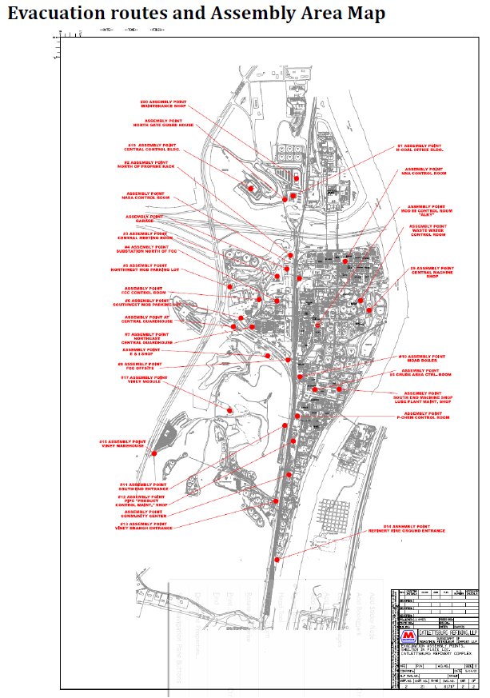


,
MPC Contractor Pre-Arrival Checklist

Company Name: |  |  | Start Date: | Stop Date:
Job Location: |  | Site Manager:
Work Description:
PART 1: SITE ENTRY REQUIREMENTS |  |  |  | YES | NO
Are all employees compliant with the DISA Consortium drug screen program?
Are all employees compliant with the background check requirements?
Do all employees have a TWIC card?
Have all employees been trained on Safety Essentials and are up to date?
Have all employees been trained on MPC Site Specific and up to date?
Has the Sit e Specific Safety Plan been submitted and approved by HES Department and
the applicable TAR/ Project Team?
Are all employees trained and qualified to perform their job duties?
PART 2: PERSONAL PROTECTIVE EQUIPMENT |  |  |  | YES | NO
Are all employees provided with proper PPE for entering the plant?
(Hard-hat, safety glasses, FRC, steel toe boot with ¼” defined heel, ear plugs, gloves, H2S monitor)
Has your company completed a PPE Hazard Assessment for scope of work?
Are all employees provided with the proper gloves based on the task/ tasks they are performing such as: cut resistant, chemical, and leather type gloves etc.?
Do all welders have hard cap welding hoods with proper attachments? (No soft caps allowed)
Are all employees trained on limitations and how to properly wear their PPE?
Do you have an H2S program and train all your employees on it?
Do your employees have a means to bump test their H2S monitors and is it readily accessible?
Do you have a means of downloading the data from the H2S monitors when there is an H2S monitor alarm and are you able to track it?

PART 3: FALL PROTECTION | YES |  | NO
Is fall protection work anticipated? (If no, proceed to Part 4)
Have all employees been trained on your procedure and MPC site procedure?
retracting lanyards, Personal self-retracting lifeline devices shall be rated for leading edge/sharp edge applications (SRL-LE). The use of shock absorbing lanyards is prohibited., adequate tie off points and understand their limitations?
If harness and SRL's don't apply or suffice, is there a written fall protection plan?
Have all employees been trained on the fall protection plan?
Has fall protection competent person been identified and will be onsite while working from height is taking place?
PART 4: BARRICADES | YES | NO
Is the use of barricaded work anticipated? (If no, proceed to Part 5.)
Have all employees been trained on your procedure and MPC site procedure?
Do you have barricade tags available for your employees?
Do you have warning lights and signage available for barricades left overnight to warn others?
PART 5 : CONFINED SPACE | YES | NO
Is confined space work anticipated? (If no, proceed to Part 6.)
Are all employees trained on your company's CSE procedure and MPC site procedure?
Have all locks been acquired by your company? (Red in Color, applied by manufacturer)
Have all attendants, entrants, and entry supervisors been trained on their responsibilities?
Have all attendants been trained on the gas monitor they will be using, it's limitations
and how to interpret monitoring results?
PART 6: ENERGY ISOLATION | YES | NO
Is energy isolation work anticipated? (If no, proceed to Part 7.)
Are all employees trained on your company's energy isolation procedure and MPC site procedure?
Do you have enough personal locks (Red in Color) purchased for your employees?
Do you have each lock individually keyed with one key available and a means to identify the owner?
PART 7: AERIAL PLATFORM / SCISSOR LIFTS | YES | NO
Is work requiring the use of a powered personnel lift anticipated? (If no, proceed to Part 8.)
Has MPC HES reviewed and approved your company's Aerial Lift policy?
Have all employees been trained on your approved Aerial lift policy and MPC inspection
and hazard assessment form?
Does the Aerial lift instructor have certifications to deliver the training?
Do all employees have operator cards to carry on their person to identify what piece of
equipment they can operate?
PART 8: FORKLIFT (POWER INDUSTRIAL TRUCK) | YES | NO
Is work requiring a forklift anticipated? (If no, proceed to Part 9.)
Have all employees been trained on your company's forklift policy and MPC policy
including inspection form?
Does the forklift instructor have certifications to deliver the training?
Do all employees have an operator card to carry on their person to identify what piece of equipment they can operate?

PART 9: RIGGING / CRANES |  |  | YES | NO
Is work requiring a crane or having any rigging requirements anticipated? (If no, proceed to Part 10.)
Are all crane operators NCCCO certified? | (15 tons or greater)
Are all employees trained on your company's rigging/ lifting policies and MPC
procedures?
Do all cranes have annual inspections up to date?
Do all cranes have adequate crane pads?
Is there a preventive maintenance program in place for your cranes?
Do you have certifications from a Licensed Engineer or Manufacturer for the lifting
beams and spreader bars?
Do you have lift plans approved by MPC?
Are up-to-date inspections for cranes, hoisting/ rigging equipment complete and
documented?
Have all riggers and signal persons received training that meets the requirements of
OSHA 1926.1400?
PART 10: MATERIAL HANDLING |  |  | YES | NO
Is work requiring the use of any rigging type equipment anticipated? (If no, proceed to Part 11.)
Have all employees received training on slings, chokers, shackles, chain falls, come-a-
longs etc. including their limitations and documentation?
Do all chain falls, come-a-longs, material baskets have documented annual inspection,
and legible load rating marked on them?
Are all slings, chokers, shackles, chain falls and come-a-longs inspected, in good condition and have documentation?
PART 11: HOT WORK |  |  | YES | NO
Is Hot Work anticipated? (If no, proceed to Part 12.)
Are all employees trained on your company's procedures and MPC site procedures?
Does your company fire hose provide, meet MPC site requirement.
Are the employees providing Fire Watch duties trained on their responsibilities?
Have all Fire Watch Attendants been trained on the gas monitor they will be using and
it's limitations?

PART 12: TRENCHING/EXCAVATIONS | YES | NO
Is trenching/excavation work anticipated? (If no, proceed to Part 13.)
Are all employees trained on your company's excavation policy and MPC site procedure?
Do you have appropriate materials for barricading and securing the work area?
Do you have an excavation competent person available to be on site at all times while work is being performed?
PART 13: RESPIRATORY PROTECTION YES NO
Is respiratory protection work anticipated? (If no, proceed to Part 14)
Are all employees trained on your company's respiratory protection procedure and MPC site procedure?
Are all employees pulmonary fit tested on the types of respirators they are going use?
Do all employees have a medical clearance to use the respirator?
Have all employees been trained on the respirators they will be using?
Do you have a cartridge change out plan for break through?
Has the bottle watch been trained on their duties?
PART 14: HAND TOOLS AND POWER TOOLS YES NO
Is work with hand tools and power tools anticipated?
Are all tools in good condition and not mushroomed, frayed, cracked, missing guards or
not modified, etc., in addition have legible safety warning stickers?
Have all employees been trained on the safe use of the tools they are going to be using?

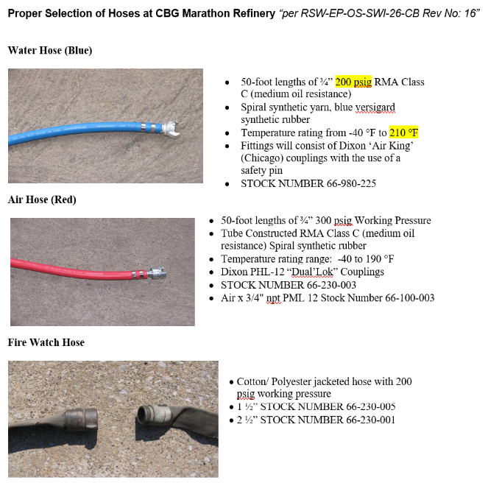

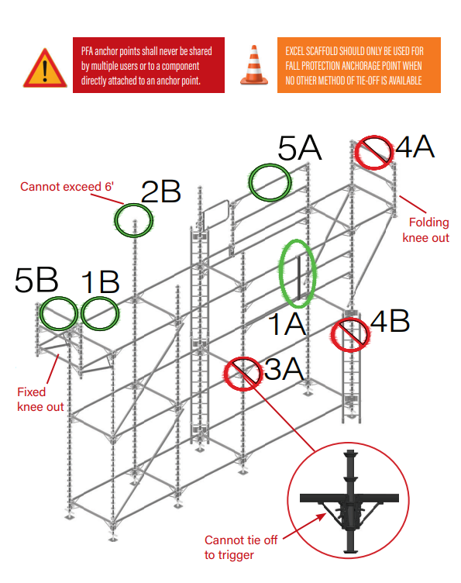

Fall protection must be used on scaffolds over 4 feet high without handrails/guardrails and when ascending or descending external scaffold ladders to unbroken heights of 20 feet or more

Supplemental scaffold access fall protection (such as a cage or barrier; or a self-retracting lifeline) shall be used when the ladder is near a break in elevation with a potential fall exposure. Examples of this include, but not limited to the following: floor holes, open sided platforms, and external handrails to which a person could fall over. Use of self-retracting lifelines shall start at the bottom of the ladder.

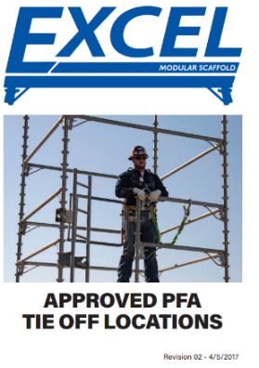
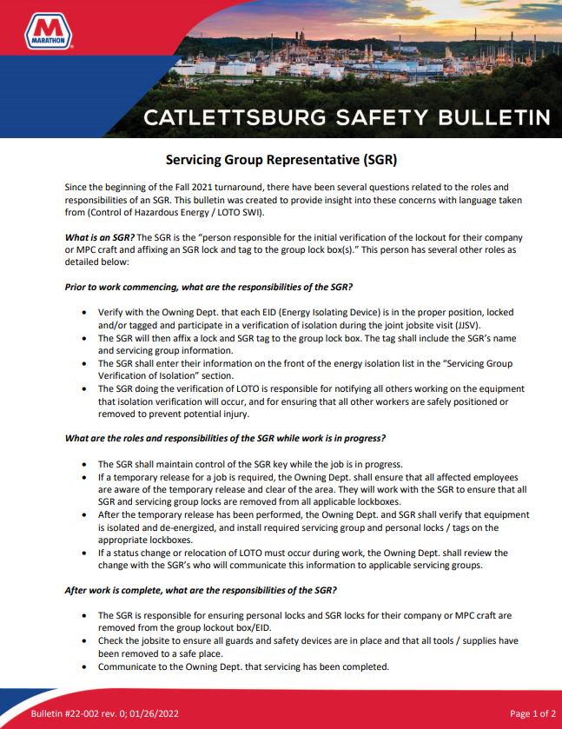
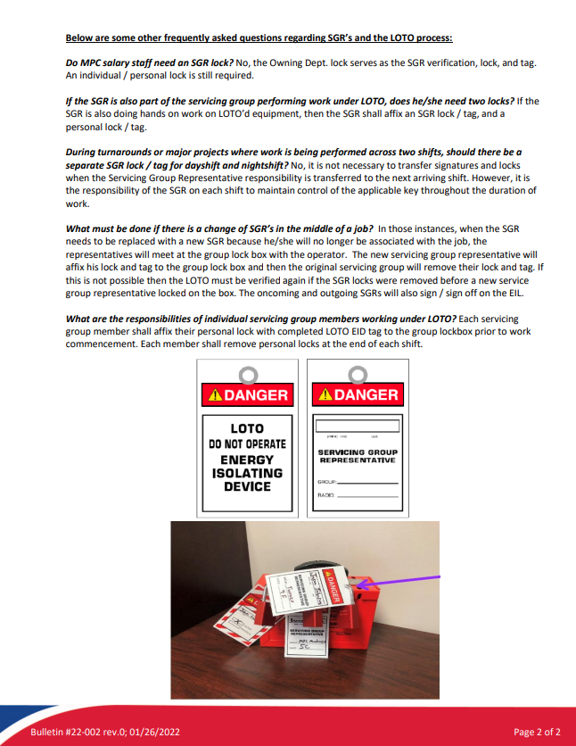
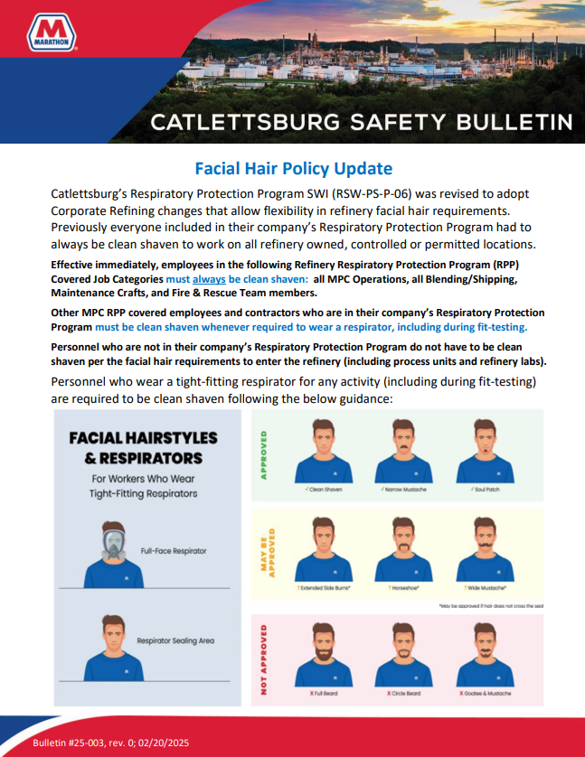
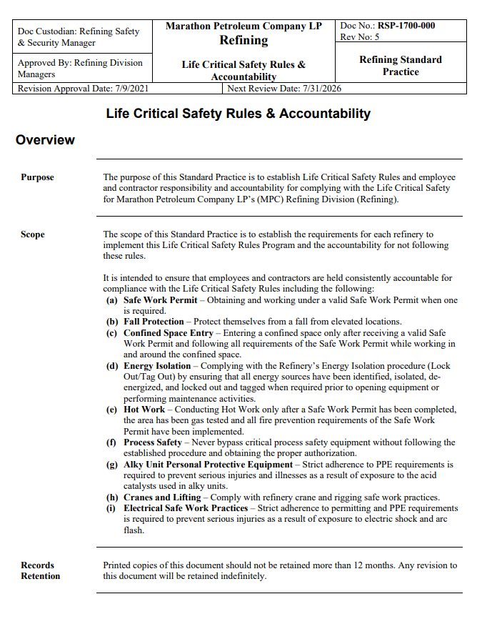

Frequently Used Forms and Safe Work Instructions (SWI)

- Confined Space Attendance Reference Sheet – Appendix F
- Deck and Railing Removal Form (Located in Permit/LOTO Area)
- Excavation and Digging Competent Person Checklist – Attachment 1
- First Break Requirements – MPC First Break Identification TAG
- Hot Tap /In-Service Weld Attachments 1 - 4
- Job Hazard Analysis (JHA) w/Drop tool and materials evaluation form- Updated 9/7/2023
- Live Flare Header Invasive Work Pre-Approval
- Maintenance Planning JHA
- Marathon Hexavalent Chromium Work Planning Protocol - Attachment 1
- MPC & Contractor Occupational Injury/Illness Incident Report
- Request for Cutoff Wheel Form- Hand & Power Tools RSW-MC-SWI-06-CB
- Rigging and Lifting - When permit/critical lifts are made, consult a SME (Subject Matter Expert) Shaun Russell (ext. 2373) or Jeremy Nott (ext. 6792)
  - Attachment 1- Daily/Shift Inspection for Fork Trucks
  - Attachment 2 – Daily/Shift Inspection for Aerial Lifts
  - Form 01- Crane Lift JSA
  - Form 04- Electrical Hazard Analysis for work near power lines
  - Overhead Crane Pre-Operation Checklist/Inspection
- Initial Pre-Entry for Confined Space; request through MPC Safety Dept.
- Fall Protection Plan for Exiting MEWP Updated 9/7/2023

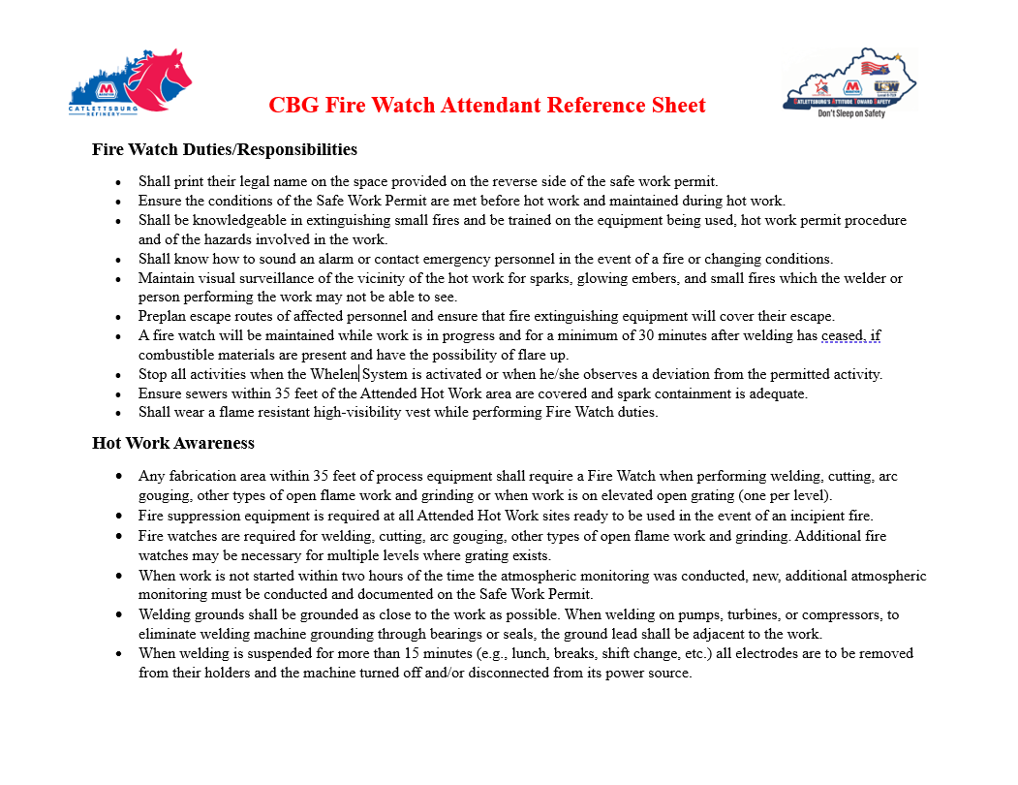

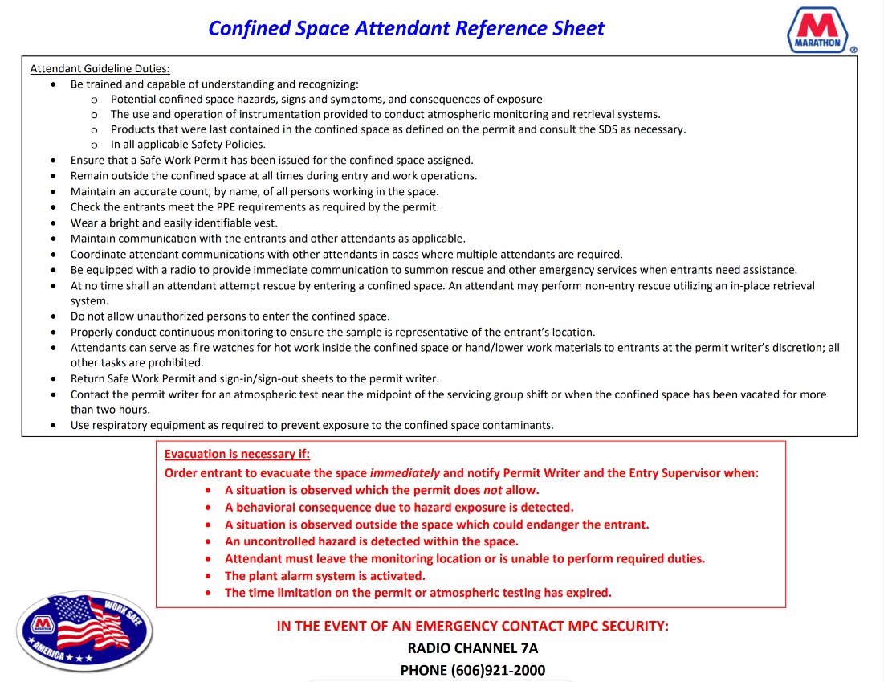

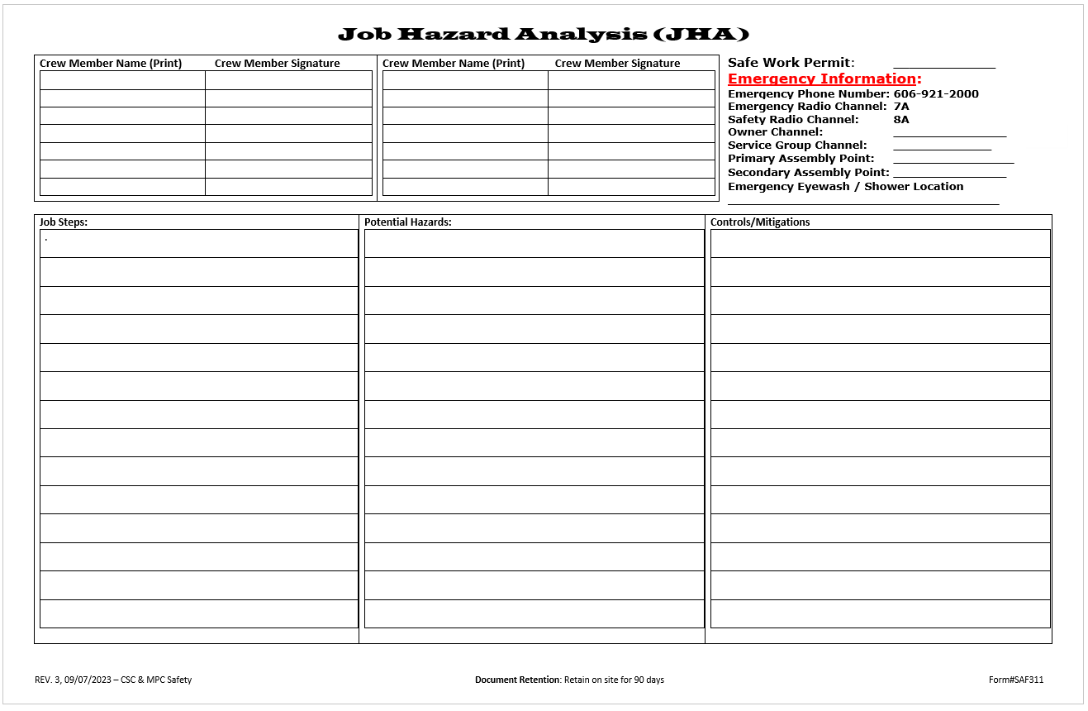
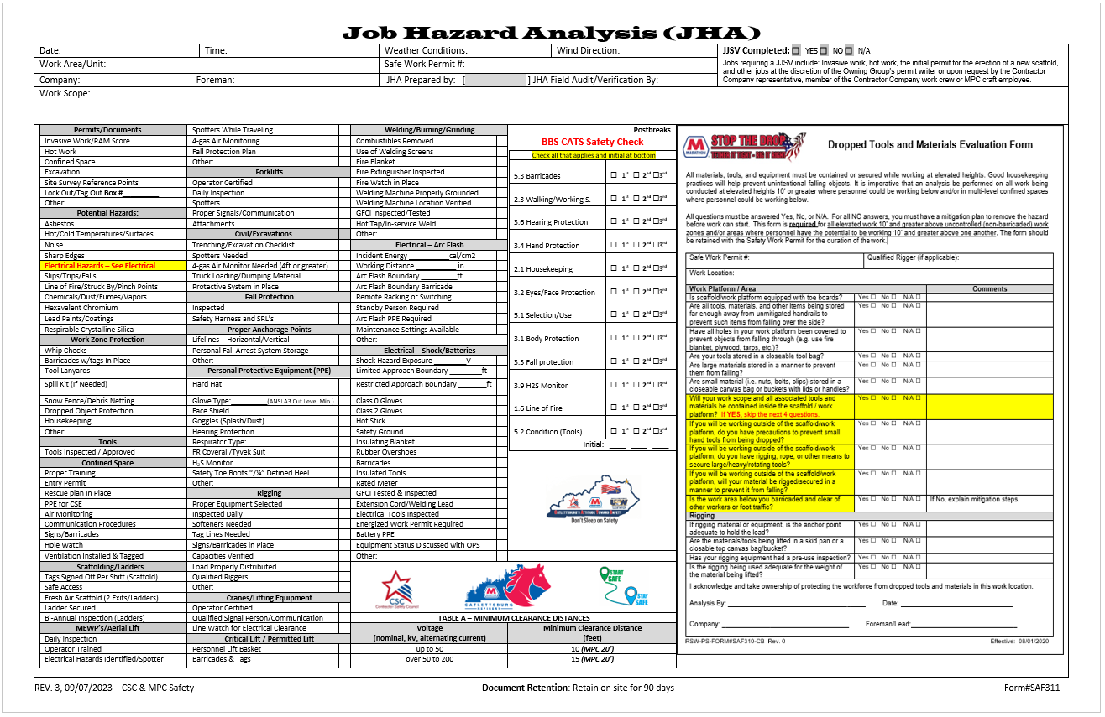
Click on icon to view document


“Please sign in to the contractor SharePoint to review the E-Permitting User Guide included in this document before proceeding with permit requests. Instructions for accessing SharePoint are provided at the end of the document.” https://mpcext.sharepoint.com/sites/MPC-Ref-Specs-Stds

Contractor Device Requirements
Permit Receiver:
- All contract companies with employees that perform work under a safe work permit must, at a minimum, provide a (singular) iOS mobile device to their employees at the physical location where the work is being performed under the permit.
- The device must be operational and available at the physical location the entire time employees are at the physical location.
- The device can be an iPad, iPad Mini, or iPhone and must have cellular connectivity (cellular plan).
Permit Writer/Editor:
- All contract companies with employees that write/fill-out portions of our current paper, safe work permit, will be required to provide those employees with an iOS mobile device, an iPad or iPad Mini with cellular connectivity (cellular plan).
Confined Space Attendants:
- All contract companies with employees that function as confined space attendants (Hole Watch) will be required to provide those employees with an iOS mobile device, an iPad or iPad Mini with cellular connectivity (cellular plan). The device must be operational and available at the physical location the entire time employees are at the physical location.
iOS Mobile Device Specification Requirements:
- iPhone: 12 or newer.
- iPad: 10th Generation or newer; cellular enabled.
- iPad Mini: 6th Generation or newer; cellular enabled.
Case Requirements:
- All mobile devices must be housed in a case that has passed the MIL STD drop test. MPC Refining recommends, Axtion Bold, Otterbox Defender Pro and Otterbox Defender cases.

Sustainability Requirements:
- Contract companies are responsible for maintaining up-to-date hardware for their employees. Devices must be capable of receiving the latest iOS updates. If a device becomes obsolete - defined as no longer receiving iOS updates from Apple - it must be replaced with a newer model that remains eligible for iOS updates.

Contractor Training Requirements
- All Embedded Contractors will be added to the training plan of their respective location and will be scheduled to receive training alongside MPC employees. This training should be considered mandatory.
- Turnaround Contractors will be trained in the new permitting system as part of TAR Contractor on-boarding, similar to how they receive training on the current paper, safe work permit.
- For all other Contractors that perform work under a safe work permit, a training plan will be determined once they are identified.

Note below was sent out to our Contractor partners by Supply Chain

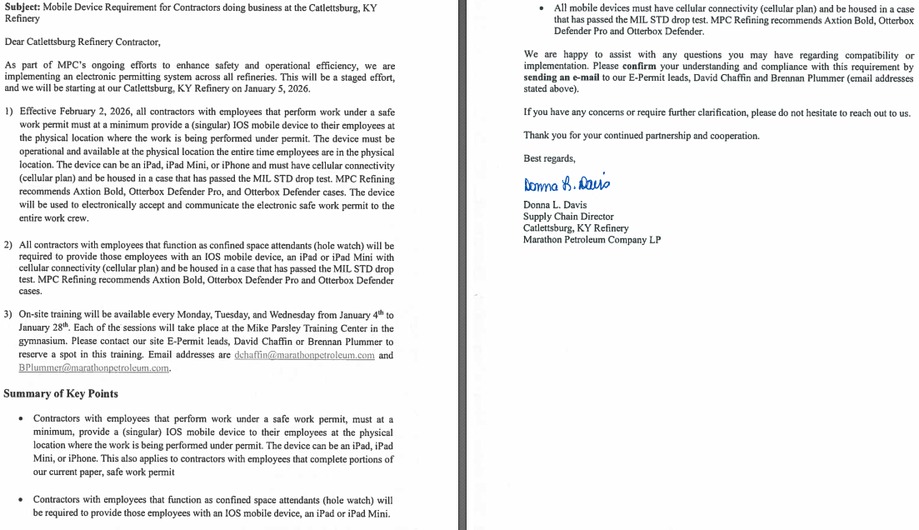

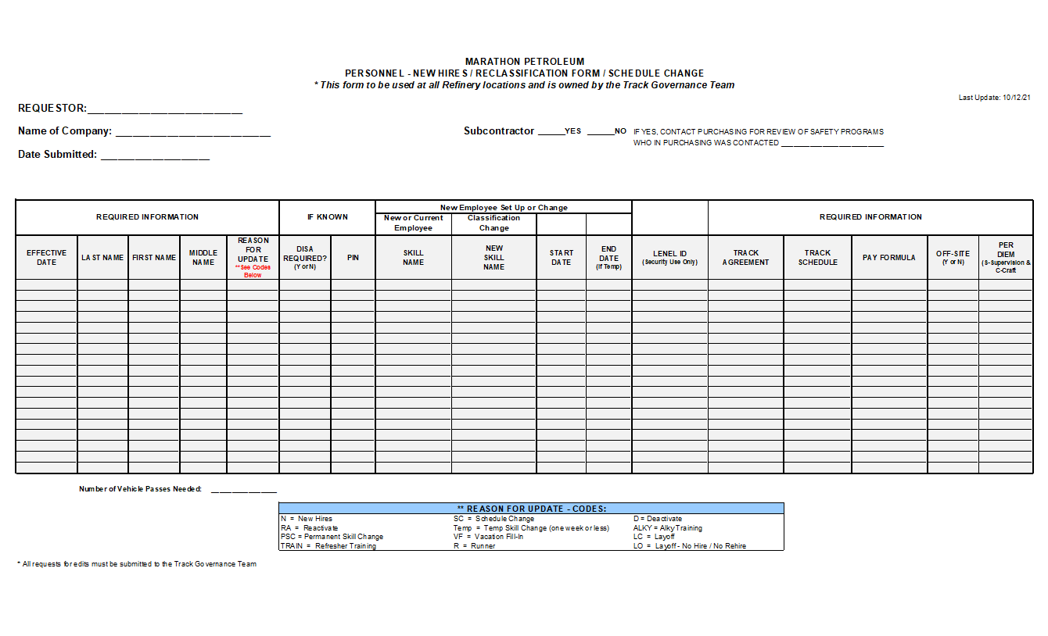
click on link for use
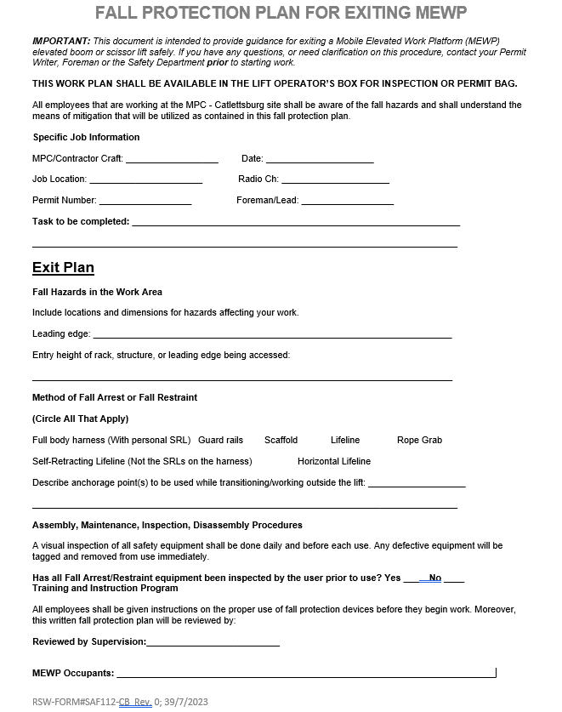
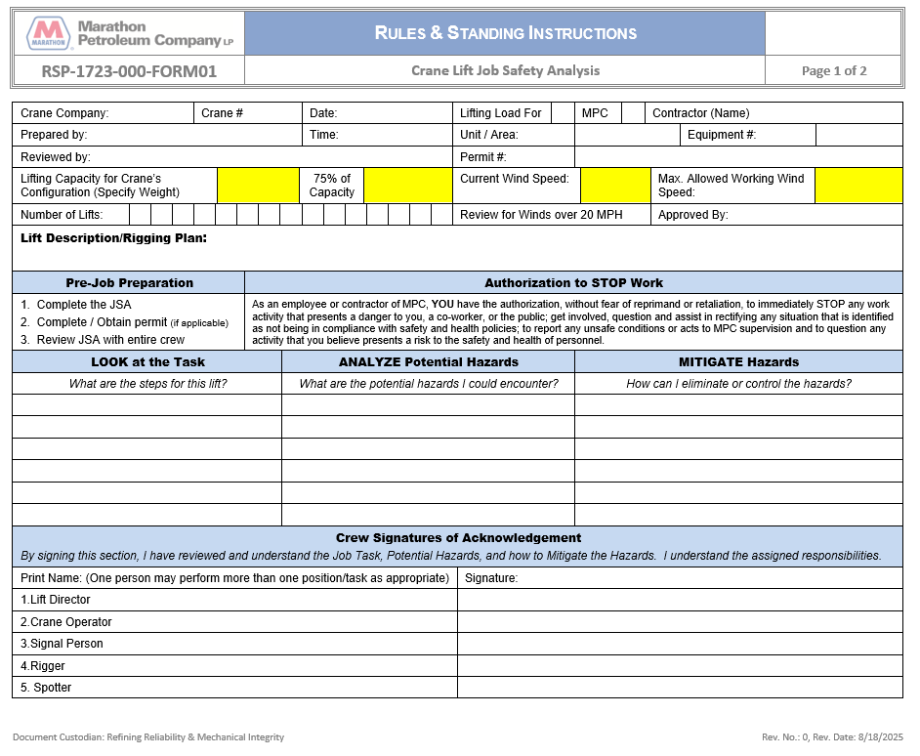

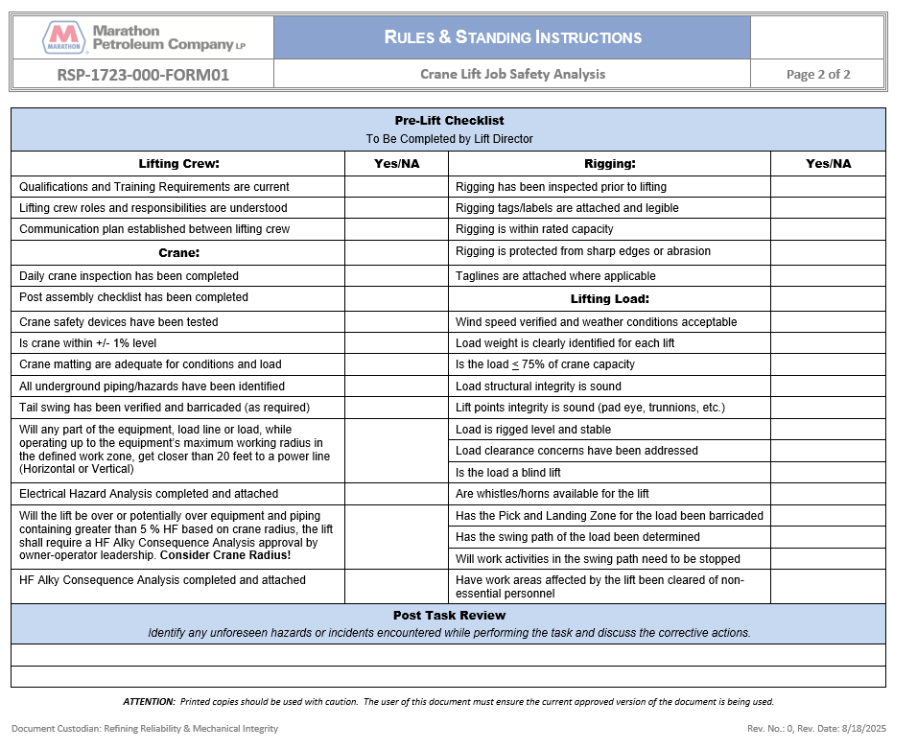

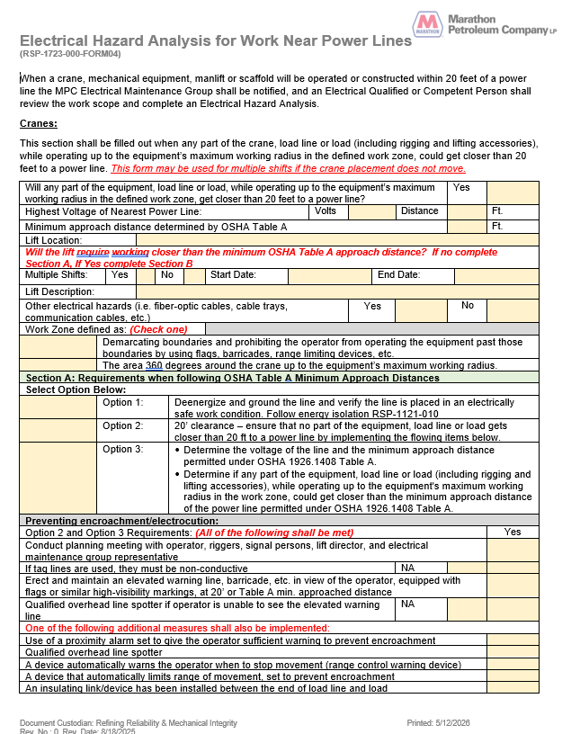

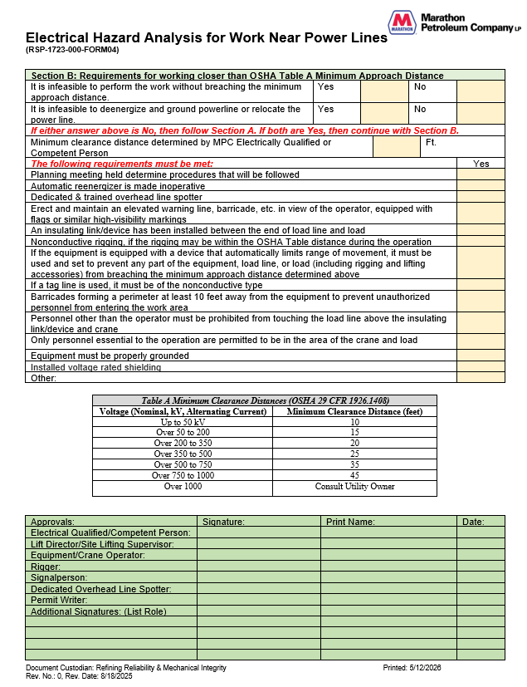

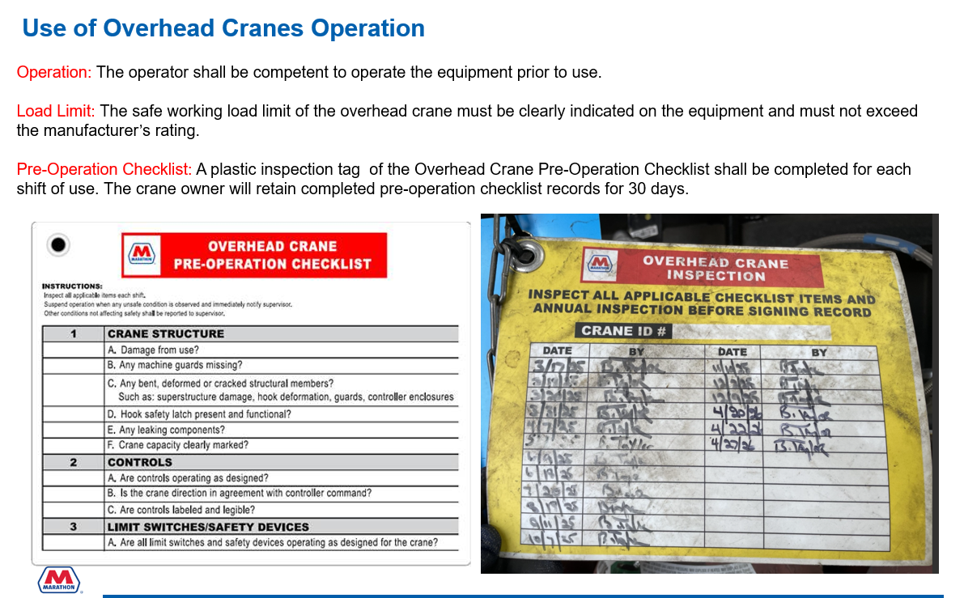

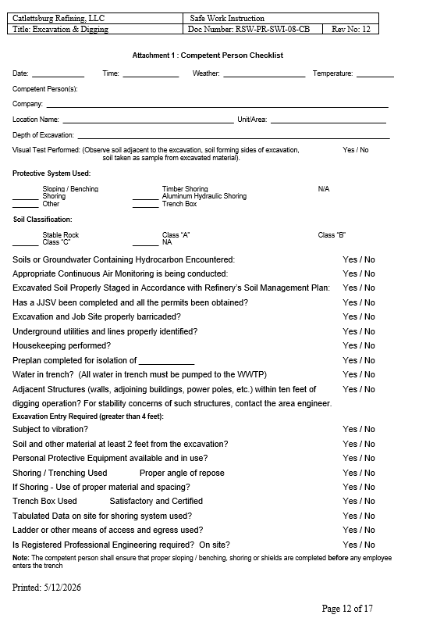

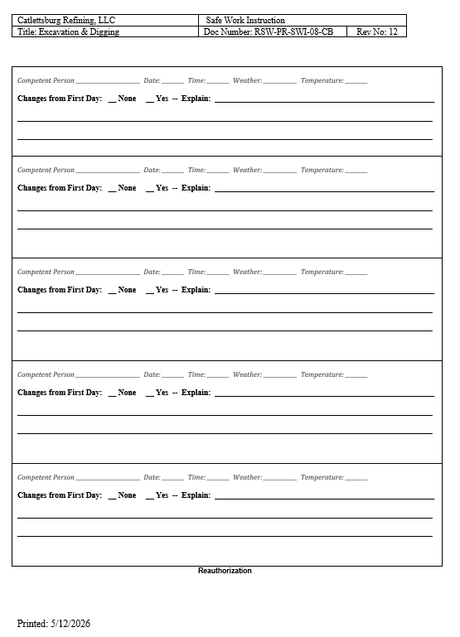

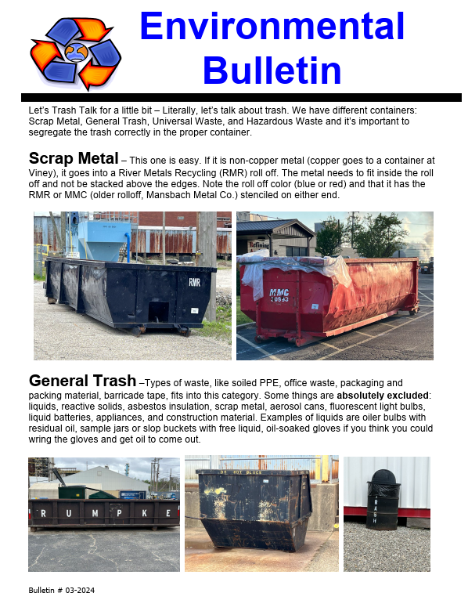

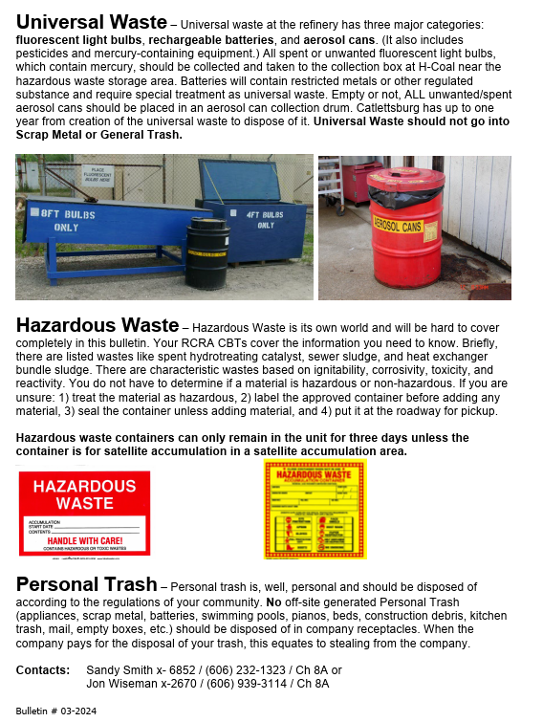

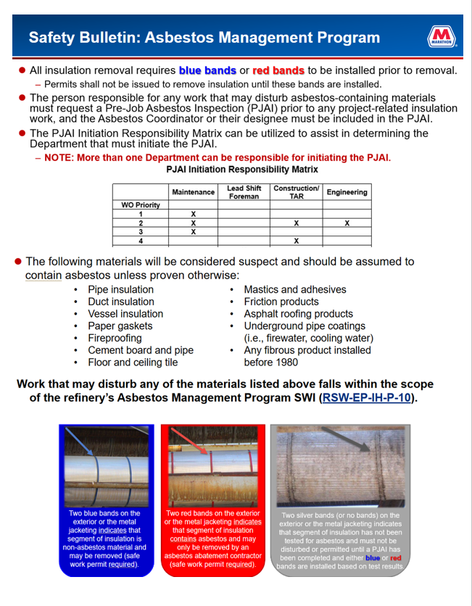

LEAD EXPOSURE CONTROL

PURPOSE
The purpose of this is to summarize Safe Work Instruction (SWI) requirements for evaluating, controlling, and preventing employee exposure to lead during refinery operations, maintenance, and construction activities.
APPLICATION
These requirements apply to all employees and contractors performing work on Catlettsburg Refining property where lead-containing materials may be disturbed, including but not limited to cutting, grinding, welding, or blasting painted surfaces; demolition or renovation of equipment or structures; battery handling; or disturbance of impacted soil or dust.
LEAD HAZARDS

Lead may enter the body by inhalation of dust or fumes or ingestion from contaminated hands, food, or beverages. Health effects may be acute or chronic and can include nervous system damage, kidney injury, high blood pressure, and reproductive effects. Lead accumulates in the body and symptoms may be delayed.
EXPOSURE LIMITS
OSHA Action Level: 30 micrograms per cubic meter (8-hour Time-Weighted Average)
OSHA Permissible Exposure Limit (PEL): 50 micrograms per cubic meter (8-hour Time-Weighted Average)
Exposures at or above these limits trigger monitoring, controls, training, and medical surveillance.
REQUIREMENTS – BEFORE YOU START WORK
Any work that may disturb lead-containing material must be identified during job planning. Industrial Hygiene must be consulted when lead exposure is reasonably foreseeable. Required permits, barricading, and postings must be in place before work begins. XRF Analyzer avaliable for rapid results,provided by I.E.I
ENGINEERING & WORK PRACTICE CONTROLS
Controls include wet methods, local exhaust ventilation, HEPA-filtered vacuums, restricted access to impacted areas, and the prohibition of dry sweeping or compressed air.
PERSONAL PROTECTIVE EQUIPMENT (PPE)
When required, PPE may include respiratory protection, protective clothing, gloves, and eye protection. Respirator use requires medical clearance, training, and fit testing.
HYGIENE REQUIREMENTS
Eating, drinking, smoking, and tobacco use are prohibited in lead work areas. Employees must wash hands and face before breaks and at the end of the shift. Contaminated clothing must not leave the work area.
EXPOSURE MONITORING & MEDICAL SURVEILLANCE
Industrial Hygiene may conduct personal and/or area air monitoring. Employees exposed above Action Levels may be enrolled in blood lead level testing and medical surveillance. Monitoring results will be communicated as required.
EMPLOYEE RESPONSIBILITIES
Employees shall follow all SWI and permit requirements, use assigned controls and PPE, report unsafe conditions, and notify supervision of suspected lead exposure.
IF UNCONTROLLED LEAD EXPOSURE IS SUSPECTED
Stop Work safely, secure the area if needed, notify supervision immediately, and contact Safety or Industrial Hygiene.

Catlettsburg Refining LLC Safe Practices and Procedures

The most recently updated version of the Catlettsburg Refining LLC Safe Practices and Procedures can
be accessed the following internet address: https://mpcext.sharepoint.com/sites/MPC-Ref-Specs-Stds

For login access, you can contact Supply Chain: Josh Runyan 606-921-6525, Tara Hester 606-921-2544 or Safety: Ashley Hall 606-921-2787

STEP 1:
Click on the hyper link https://mpcext.sharepoint.com/sites/MPC-Ref-Specs-Stds

STEP 2:
Sign in with one of the five user accounts and passwords.
Account | Password
CBGSafety01@mpcext.microsoftonline.com | Safety01
CBGSafety02@mpcext.microsoftonline.com | Safety02
CBGSafety03@mpcext.microsoftonline.com | Safety03
CBGSafety04@mpcext.microsoftonline.com | Safety04
CBGSafety05@mpcext.microsoftonline.com | Safety05

Enter one of the 5 account names in the Sign In box.


Enter the password corresponding to the account.
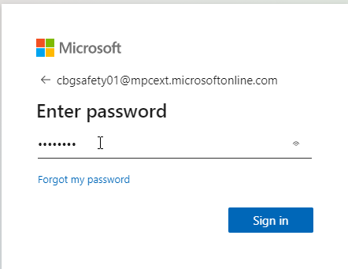

If asked to stay signed in, always click ‘No’. This will allow other people to use the account without issues.
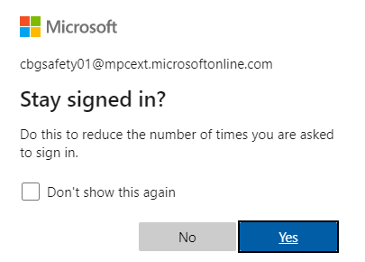

If you get an error like the following screen shot, try clicking on the first link that says, ‘Click here to sign in with a different account to this site.’
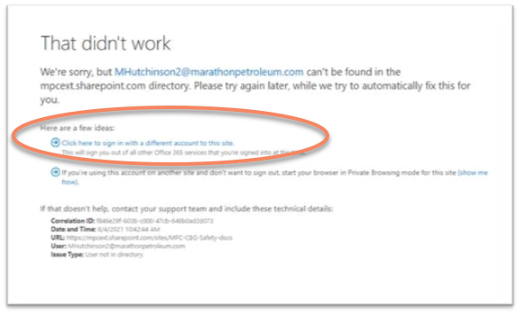

Click on Catlettsburg Safe Work Instructions.

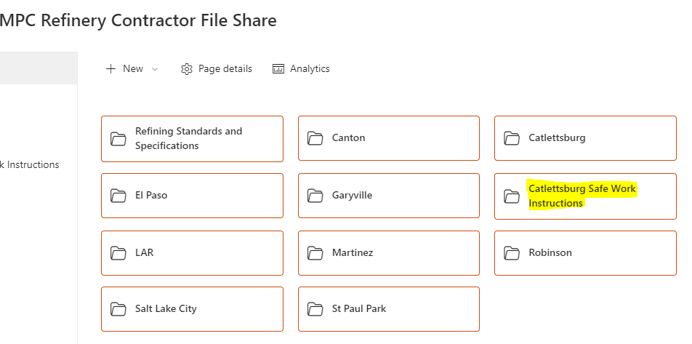

Documents are sorted by alphabetical order. Click on the Name column to open the document.
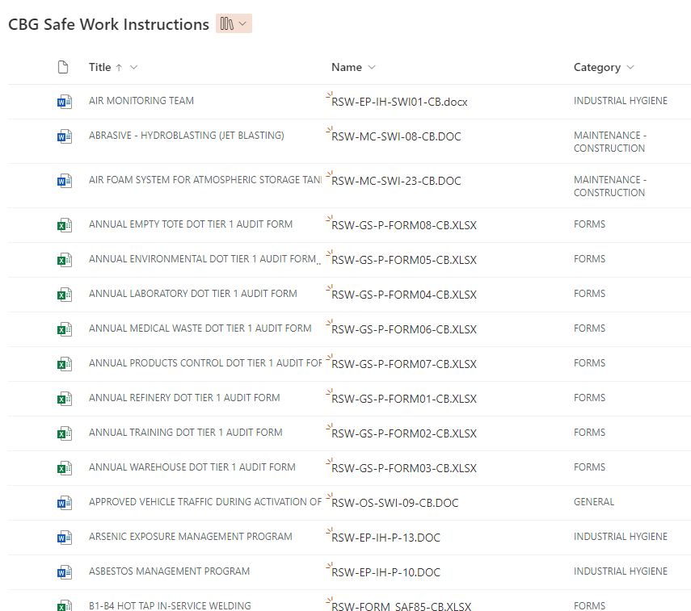

Click the large C in the upper right corner of the screen, the ‘Sign Out’ to log off the site.

Updated 5/20/2026

