Form PR-33A Authorization for Surface Preparation on
Process/ Utility Piping and Equipment Under Pressure and/or in Service

Line Number or Vessel Number: _______________ Date: ________________
Ref. Dwg. No.: _____________________________ Work Package – JN#: ____________________________
Blasting Company Name: ____________________ Estimated Date to Start Work: _____________________
Surface Preparation Method:
Scope:
Process Service: _____________________________ Process Material: _____________________________________
Oper. Temp: __________________ Oper. Press.: ____________________ Autoignition Temp: ___________________
Water Cleaning below 5000 psi and Hand Tool Cleaning Assessment
Water Jetting & Hand Tool Cleaning allowed without additional thickness testing under the following conditions:
- There is no external corrosion (verified by field visual)
- Inspection history shows no internal corrosion that will impact the safety of the cleaning.
- The inspector agrees there is no additional reason for thickness testing.
Inspector:
Name Signature Date
Note: If box is checked and Inspector has signed, then thickness testing and risk assessment are not required.
Thickness Testing and Risk Assessment
Inspector/Company:  UT Tech/Company:  Safe to descale?  Yes No | Minimum thickness (T-min): 1) _____________ 2) __________ 3) ____________  Pipe Diameter/Nominal thickness: 1) _____________ 2) __________ 3) ____________  Actual thickness (Tact) as found 1) _____________ 2) __________ 3) ____________  Special Instructions or Holds: _________________________________________________  Attachment Page with minimum: Date of testing, T-min, Nominal Thickness, Actual thickness, and special instructions or holds.
Likelihood Assessment Outcome
Wall Thickness: Tact can’t be determined, or Tact ≤ Tmin
Probability: High Until Fitness for Service evaluation is completed
Action Required: Fitness for Service required to verify job is safe and Contingency Plan completed and approved.

Wall Thickness: Tmin < Tact ≤ Tmin + 0.04” (The actual thickness is greater than Tmin, but less than or equal to Tmin + 0.04)
Probability: Medium
Action Required: Engineering Evaluation Completed by Unit Maintenance Engineer and Contingency Plan completed and approved

Safe to Proceed: Yes No

Unit Maintenance Engineer:
Name Signature Date

Wall Thickness: Tact > Tmin + 0.04”
Probability: Low
Action Required: Contingency Plan completed and approved if required.

RAM Score
RAM Score | 1 | Med | High | High
 | 2 | Med | Med | High
 | 3 | Low | Med | Med
 | 10 | Low | Low | Med
 |  | Low | Med | High
 | Likelihood Assessment Outcome
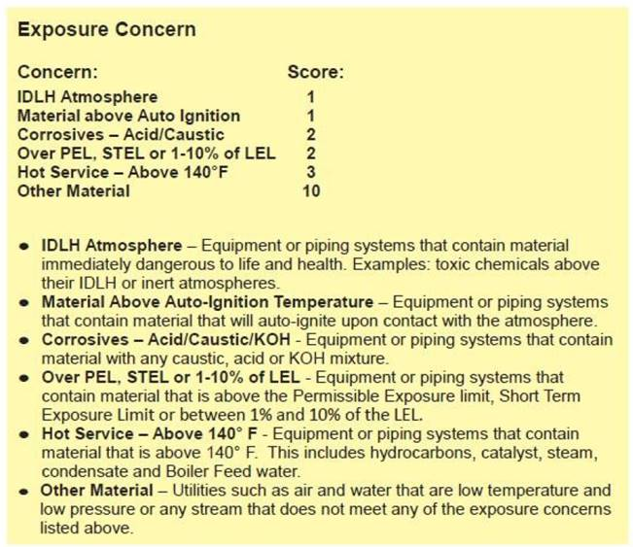
Calculated Risk Assessment: |  |  | Low | Medium | High
□ | Inspection is completed and results documented and attached.  For High or Medium Risk Assessment Outcome:  Design and operating conditions (pressure and temperature) have been verified by Inspection. | Additional Comments:
Name: Signature: Date:
Inspector
□ | Owning department has completed required contingency plan and understands hazards associated with the task.  Contingency Plan PR-33B approved and attached. | Additional Comments:
Name: Signature: Date:
Operations Maintenance Coordinator or Designee

□ | Lead testing conducted if required  Work area clearly defined and communicated to Surface Preparation Contractor | Lead Plan Required: □ Yes □ Not Applicable
 |  | Additional Comments:
Name: Signature: Date:
MPC Servicing Group Coordinator

This form must be properly authorized per PR-3 Safe Work Permit Procedure.

This form is valid for up to 90 days after the inspector signed.
Attach inspection results and risk assessment with results to this form.
Attach this form to the SWP and post at the job site. After job completion, file with last Safe Work Permit.

